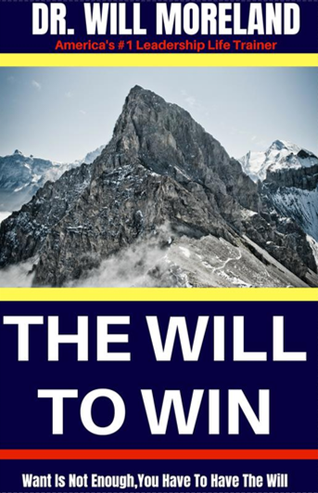

Copyright © 2015 by Moreland Publishing Group
The Will To Win
By Dr. Will Moreland

Visit us at:
www.drwillspeaks.com

Connect with us at:
Facebook: www.facebook.com/drwillspeaks
Instagram: @drwillspeaks
Email: info@drwillspeaks.com
Website: www.drwillspeaks.com

Printed in the United States of America.

All rights reserved under International Copyright Law. Contents and/or cover may not be reproduced in whole or part in any form without the express written consent of the writer.

Moreland Publishing Group
4802 E. Ray Rd.
Ste. 23-122
Phoenix, Az 85044

INDUSTRY LEADERS AGREE,
DR. WILL IS ONE OF THE BEST SPEAKERS AND TRAINERS

“Dr. Will is an excellent trainer and speaker. I have had the pleasure to listen to him speak several times and I am always inspired by his words.”
-Jerry Colangelo
One of the most innovative and influential owners in NBA history. A Basketball Hall of Fame Inductee.

“Will is a dear friend. He has supported my mission and has spoken for my organization sharing an electrifying speech that many of the staff still speak about.”
-Jimmy Walker
Founder and Chairman Celebrity Fight Night
Foundation, Inc.

“The strategies Dr. Will shared with me helped me clarify my goals and build my brand with speed. He is a true genius.”
-Jen Welter
First female to Coach in the National Football League. First female to start in a men’s professional league.

“Brilliant, Brilliant, Brilliant!!! That’s how you describe
Dr. Will. He is wise far beyond his years. I simply love working with him and sharing ideas.
-Dr. Dolf De Roos
New York Times Bestselling Author and
International Real Estate Trainer
“Dr. Will is one of our shining stars and true Leaders in our community. He knows how to command the stage and keep the audience’s attention.”
-Dr. George Fraser
Founder of Power Networking Conference
and FraserNet the Largest African American
Networking Group

“I had the pleasure to share the stage with Dr. Will and he simply is amazing to listen to. His story will motivate anyone to change their life and become better.”
-Jim Amos
Past Chairman: The International Franchise Association Chairman Emeritus: Mail Boxes Etc., now The UPS Store

“Dr. Will is the personification of greatness. And what he is doing is allowing you to peek into his Genius mind. When you are ready to go for your greatness, Dr. Will is the man.”
-Les Brown
The World’s #1 Motivational Speaker and
Inductee into the Speakers Hall of Fame

“Dr. Will helped me launch my Speaking Business and release my first book, which became a Bestseller. His strategies made it easy to accomplish my dream of writing a book. Great trainer.”
-JJ Birden
Former NFL Wide Receiver, Bestselling Author
and Entrepreneur

“I had the pleasure of hearing Dr. Will speak and he blew everyone away. His story is amazing. His style of story-telling is phenomenal.”
-Kenneth Holdman
Senior Vice President, SodexoMAGIC
“Will is a young man with a passion to help others navigate their path toward a more fulfilling and successful life. Great insights and wisdom on living a better life.”
-Denis Waitley
One of America's most respected authors, keynote lecturers and productivity consultants on high performance human achievement.

“His leadership teaching is so fresh, so relevant, so needed, so beautifully expressed, and so vital to the kind of change we all must undergo to succeed in this world of today. I had the great pleasure of working with Dr. Will during my time at Grand
Canyon University.”
-Dr. Ken Blanchard
Ken Blanchard is a prominent, sought-after author, speaker, and business consultant. New York Times
Bestselling Author of “The One Minute Manager”

"Nothing is more urgent than leadership, integrity and cause capitalism in our world, and few offer better perspective and action steps for successfully offering all three than Dr. Will."
-Steve Down
Founder of Multiple Companies, Even Steven’s Sandwich, Steve Hotels, Financially Fit and Blue Hat Construction

"Dr. Will is one of the most inspiring men of our time. And he has the rare ability to motivate every leader, employee and organization."
-Ken Jennings
CEO and Founder Mr. ReKey,
The Nation’s Largest Locksmith Company

Dedication

For the last 20 years my wife and my family have shared me with the world. They know and understand that I am passionate about the work I do and my genuine desire to help people live their best life. They make it extremely easy for me to do what I do. I hope I make them proud and the many sacrifices have been worth it!

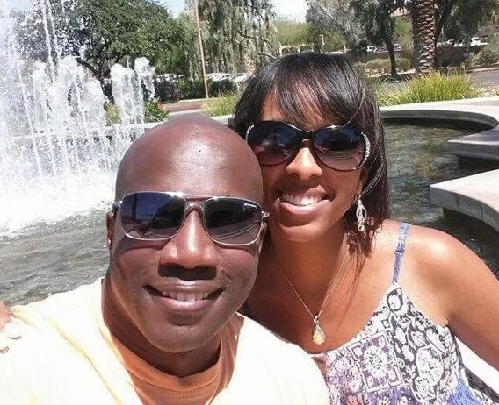

My Wife

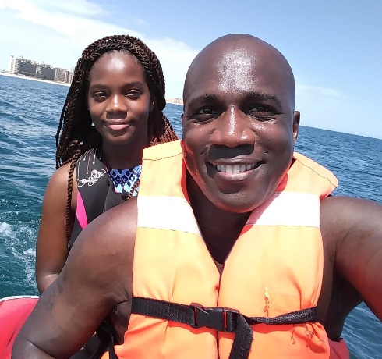

My Daughter
My Son

IMPACT * INSPIRE * INFLUENCE
“Share This Book”

Retail $24.95

Special Quantity Discounts
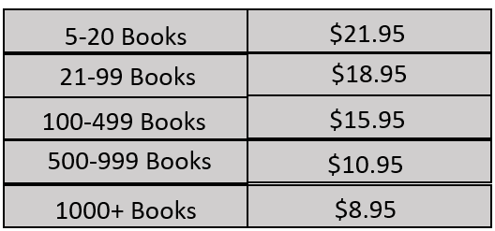

To Place an Order Contact:
(480) 442-3056
Info@drwillspeaks.com
www.drwillspeaks.com
BRING IN ONE OF
THE MOST REQUESTED
SPEAKERS FOR YOUR
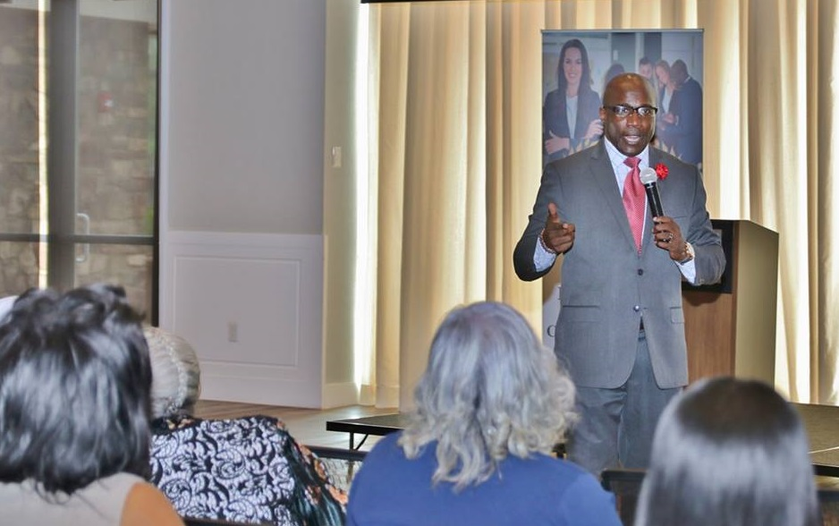
NEXT EVENT
TO CONTACT OR BOOK DR. WILL TO SPEAK:

Dr. Will Speaks, LLC
4802 E. RAY RD
STE. 23-122
Phoenix, Az 85044
(480) 442-3056
Info@drwillspeaks.com
www.drwillspeaks.com
GIVE ME THE MIC
SPEAKERS TRAINING™
Each October Speakers from Across the World Meet in Phoenix, Arizona To Be A Part of The #1 Speakers Training for Highly Paid Speakers.

Learn More:
www.drwillspeaks.com

Other Books By Dr. Will
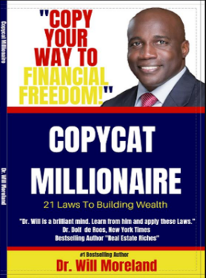
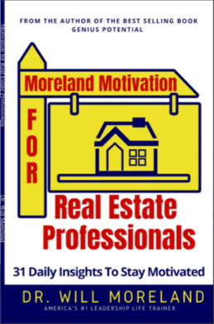
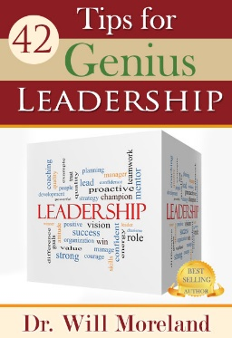
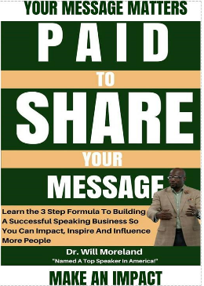
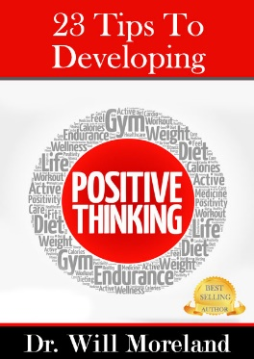
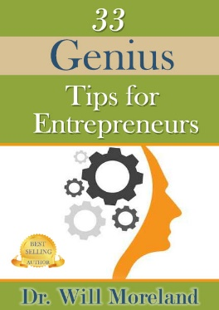
About Dr. Will
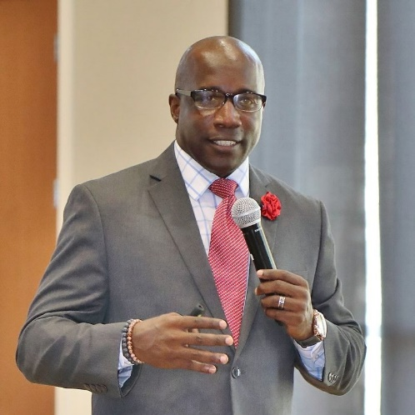
Dr. Will is recognized as one of the leading business consultants and Speakers for Success, Transformation and Leadership in the world. He has been named a Top Speaker and Business Person of the Year. Dr. Will has delivered over 1500 presentations for corporations, associations, business groups, colleges, universities and churches worldwide. He has spoken in over 40 countries, speaking for group ranging from 20-15,000.

www.drwillspeaks.com

He is the Bestselling Author of over 40 books and trains other Speakers on how to build a thriving Speaking Business. He works with athletes, authors, celebrities, business professionals, government officials and thought leaders.

He is the founder and creator of the “Give Me The Mic” Speakers Training. Each year he trains other Speakers how to become Highly Paid and Recognized as Industry Leaders.

Dr. Will founded the “Genius Speakers Academy” to provide Speakers with the tools and strategies to build thriving Speaker Businesses and create the life they love.

